**Chapter 4. Structured API Overview**

This part of the book will be a deep dive into Spark’s Structured APIs. The Structured APIs are a tool for manipulating all sorts of data, from unstructured log files to semi-structured CSV files and highly structured Parquet files. These APIs refer to three core types of distributed collection APIs:

* Datasets
* DataFrames
* SQL tables and views

Although they are distinct parts of the book, the majority of the Structured APIs apply to both *batch* and *streaming* computation. This means that when you work with the Structured APIs, it should be simple to migrate from batch to streaming (or vice versa) with little to no effort. We’ll cover streaming in detail in [Part V](https://www.safaribooksonline.com/library/view/spark-the-definitive/9781491912201/part05.html#part5).

The Structured APIs are the fundamental abstraction that you will use to write the majority of your data flows. Thus far in this book, we have taken a tutorial-based approach, meandering our way through much of what Spark has to offer. This part offers a more in-depth exploration. In this chapter, we’ll introduce the fundamental concepts that you should understand: the typed and untyped APIs (and their differences); what the core terminology is; and, finally, how Spark actually takes your Structured API data flows and executes it on the cluster. We will then provide more specific task-based information for working with certain types of data or data sources.

**NOTE**

Before proceeding, let’s review the fundamental concepts and definitions that we covered in [Part I](https://www.safaribooksonline.com/library/view/spark-the-definitive/9781491912201/part01.html#part1). Spark is a distributed programming model in which the user specifies *transformations*. Multiple transformations build up a directed acyclic graph of instructions. An action begins the process of executing that graph of instructions, as a single job, by breaking it down into stages and tasks to execute across the cluster. The logical structures that we manipulate with transformations and actions are DataFrames and Datasets. To create a new DataFrame or Dataset, you call a transformation. To start computation or convert to native language types, you call an action.

**DataFrames and Datasets**

[Part I](https://www.safaribooksonline.com/library/view/spark-the-definitive/9781491912201/part01.html#part1) discussed DataFrames. Spark has two notions of structured collections: DataFrames and Datasets. We will touch on the (nuanced) differences shortly, but let’s define what they both represent first.

DataFrames and Datasets are (distributed) table-like collections with well-defined rows and columns. Each column must have the same number of rows as all the other columns (although you can use null to specify the absence of a value) and each column has type information that must be consistent for every row in the collection. To Spark, DataFrames and Datasets represent immutable, lazily evaluated plans that specify what operations to apply to data residing at a location to generate some output. When we perform an action on a DataFrame, we instruct Spark to perform the actual transformations and return the result. These represent plans of how to manipulate rows and columns to compute the user’s desired result.

**NOTE**

Tables and views are basically the same thing as DataFrames. We just execute SQL against them instead of DataFrame code. We cover all of this in [Chapter 10](https://www.safaribooksonline.com/library/view/spark-the-definitive/9781491912201/ch10.html#s2c7_spark_sql), which focuses specifically on Spark SQL.

To add a bit more specificity to these definitions, we need to talk about schemas, which are the way you define the types of data you’re storing in this distributed collection.

**Schemas**

A schema defines the column names and types of a DataFrame. You can define schemas manually or read a schema from a data source (often called *schema on read*). Schemas consist of types, meaning that you need a way of specifying what lies where.

**Overview of Structured Spark Types**

Spark is effectively a programming language of its own. Internally, Spark uses an engine called *Catalyst* that maintains its own type information through the planning and processing of work. In doing so, this opens up a wide variety of execution optimizations that make significant differences. Spark types map directly to the different language APIs that Spark maintains and there exists a lookup table for each of these in Scala, Java, Python, SQL, and R. Even if we use Spark’s Structured APIs from Python or R, the majority of our manipulations will operate strictly on *Spark types*, not Python types. For example, the following code does not perform addition in Scala or Python; it actually performs addition *purely in Spark*:

*// in Scala*

**val** df **=** spark.range(500).toDF("number")

df.select(df.col("number") + 10)

*# in Python*

df = spark.range(500).toDF("number")

df.select(df["number"] + 10)

This addition operation happens because Spark will convert an expression written in an input language to Spark’s internal Catalyst representation of that same type information. It then will operate on that internal representation. We touch on why this is the case momentarily, but before we can, we need to discuss Datasets.

**DataFrames Versus Datasets**

In essence, within the Structured APIs, there are two more APIs, the “untyped” DataFrames and the “typed” Datasets. To say that DataFrames are untyped is aslightly inaccurate; they have types, but Spark maintains them completely and only checks whether those types line up to those specified in the schema at *runtime*. Datasets, on the other hand, check whether types conform to the specification at *compile time*. Datasets are only available to Java Virtual Machine (JVM)–based languages (Scala and Java) and we specify types with case classes or Java beans.

For the most part, you’re likely to work with DataFrames. To Spark (in Scala), DataFrames are simply Datasets of Type Row. The “Row” type is Spark’s internal representation of its optimized in-memory format for computation. This format makes for highly specialized and efficient computation because rather than using JVM types, which can cause high garbage-collection and object instantiation costs, Spark can operate on its own internal format without incurring any of those costs. To Spark (in Python or R), there is no such thing as a Dataset: everything is a DataFrame and therefore we always operate on that optimized format.

**NOTE**

The internal Catalyst format is well covered in numerous Spark presentations. Given that this book is intended for a more general audience, we’ll refrain from going into the implementation. If you’re curious, there are some excellent talks by [Josh Rosen](https://youtu.be/5ajs8EIPWGI) and [Herman van Hovell](https://youtu.be/GDeePbbCz2g), both of Databricks, about their work in the development of Spark’s Catalyst engine.

Understanding DataFrames, Spark Types, and Schemas takes some time to digest. What you need to know is that when you’re using DataFrames, you’re taking advantage of Spark’s optimized internal format. This format applies the same efficiency gains to all of Spark’s language APIs. If you need strict compile-time checking, read [Chapter 11](https://www.safaribooksonline.com/library/view/spark-the-definitive/9781491912201/ch11.html#s2c8---datasets) to learn more about it.

Let’s move onto some friendlier and more approachable concepts: columns and rows.

**Columns**

Columns represent a *simple type* like an integer or string, a *complex type* like an array or map, or a *null value*. Spark tracks all of this type information for you and offers a variety of ways, with which you can transform columns. Columns are discussed extensively in [Chapter 5](https://www.safaribooksonline.com/library/view/spark-the-definitive/9781491912201/ch05.html#s2c2---basic-structured-operations), but for the most part you can think about Spark Column types as columns in a table.

**Rows**

A row is nothing more than a record of data. Each record in a DataFrame must be of type Row, as we can see when we collect the following DataFrames. We can create these rows manually from SQL, from Resilient Distributed Datasets (RDDs), from data sources, or manually from scratch. Here, we create one by using a range:

*// in Scala*

spark.range(2).toDF().collect()

*# in Python*

spark.range(2).collect()

These both result in an array of Row objects.

**Spark Types**

We mentioned earlier that Spark has a large number of internal type representations. We include a handy reference table on the next several pages so that you can most easily reference what type, in your specific language, lines up with the type in Spark.

Before getting to those tables, let’s talk about how we instantiate, or declare, a column to be of a certain type.

To work with the correct Scala types, use the following:

**import** **org.apache.spark.sql.types._**

**val** b **=** **ByteType**

To work with the correct Java types, you should use the factory methods in the following package:

**import** **org.apache.spark.sql.types.DataTypes**;

ByteType x = DataTypes.ByteType;

Python types at times have certain requirements, which you can see listed in Table 4-1, as do Scala and Java, which you can see listed in Tables 4-2 and 4-3, respectively. To work with the correct Python types, use the following:

**from** **pyspark.sql.types** **import** *

b = ByteType()

The following tables provide the detailed type information for each of Spark’s language bindings.

*Table 4-1. Python type reference*

|  |  |  |
| --- | --- | --- |
| **Data type** | **Value type in Python** | **API to access or create a data type** |
| ByteType | int or long. Note: Numbers will be converted to 1-byte signed integer numbers at runtime. Ensure that numbers are within the range of –128 to 127. | ByteType() |
| ShortType | int or long. Note: Numbers will be converted to 2-byte signed integer numbers at runtime. Ensure that numbers are within the range of –32768 to 32767. | ShortType() |
| IntegerType | int or long. Note: Python has a lenient definition of “integer.” Numbers that are too large will be rejected by Spark SQL if you use the IntegerType(). It’s best practice to use LongType. | IntegerType() |
| LongType | long. Note: Numbers will be converted to 8-byte signed integer numbers at runtime. Ensure that numbers are within the range of –9223372036854775808 to 9223372036854775807. Otherwise, convert data to decimal.Decimal and use DecimalType. | LongType() |
| FloatType | float. Note: Numbers will be converted to 4-byte single-precision floating-point numbers at runtime. | FloatType() |
| DoubleType | float | DoubleType() |
| DecimalType | decimal.Decimal | DecimalType() |
| StringType | string | StringType() |
| BinaryType | bytearray | BinaryType() |
| BooleanType | bool | BooleanType() |
| TimestampType | datetime.datetime | TimestampType() |
| DateType | datetime.date | DateType() |
| ArrayType | list, tuple, or array | ArrayType(elementType, [containsNull]). Note: The default value of containsNull is True. |
| MapType | dict | MapType(keyType, valueType, [valueContainsNull]). Note: The default value of valueContainsNull is True. |
| StructType | list or tuple | StructType(fields). Note: fields is a list of StructFields. Also, fields with the same name are not allowed. |
| StructField | The value type in Python of the data type of this field (for example, Int for a StructField with the data type IntegerType) | StructField(name, dataType, [nullable]) Note: The default value of nullable is True. |

*Table 4-2. Scala type reference*

|  |  |  |
| --- | --- | --- |
| **Data type** | **Value type in Scala** | **API to access or create a data type** |
| ByteType | Byte | ByteType |
| ShortType | Short | ShortType |
| IntegerType | Int | IntegerType |
| LongType | Long | LongType |
| FloatType | Float | FloatType |
| DoubleType | Double | DoubleType |
| DecimalType | java.math.BigDecimal | DecimalType |
| StringType | String | StringType |
| BinaryType | Array[Byte] | BinaryType |
| BooleanType | Boolean | BooleanType |
| TimestampType | java.sql.Timestamp | TimestampType |
| DateType | java.sql.Date | DateType |
| ArrayType | scala.collection.Seq | ArrayType(elementType, [containsNull]). Note: The default value of containsNull is true. |
| MapType | scala.collection.Map | MapType(keyType, valueType, [valueContainsNull]). Note: The default value of valueContainsNull is true. |
| StructType | org.apache.spark.sql.Row | StructType(fields). Note: fields is an Array of StructFields. Also, fields with the same name are not allowed. |
| StructField | The value type in Scala of the data type of this field (for example, Int for a StructField with the data type IntegerType) | StructField(name, dataType, [nullable]). Note: The default value of nullable is true. |

*Table 4-3. Java type reference*

|  |  |  |
| --- | --- | --- |
| **Data type** | **Value type in Java** | **API to access or create a data type** |
| ByteType | byte or Byte | DataTypes.ByteType |
| ShortType | short or Short | DataTypes.ShortType |
| IntegerType | int or Integer | DataTypes.IntegerType |
| LongType | long or Long | DataTypes.LongType |
| FloatType | float or Float | DataTypes.FloatType |
| DoubleType | double or Double | DataTypes.DoubleType |
| DecimalType | java.math.BigDecimal | DataTypes.createDecimalType() DataTypes.createDecimalType(precision, scale). |
| StringType | String | DataTypes.StringType |
| BinaryType | byte[] | DataTypes.BinaryType |
| BooleanType | boolean or Boolean | DataTypes.BooleanType |
| TimestampType | java.sql.Timestamp | DataTypes.TimestampType |
| DateType | java.sql.Date | DataTypes.DateType |
| ArrayType | java.util.List | DataTypes.createArrayType(elementType). Note: The value of containsNull will be true DataTypes.createArrayType(elementType, containsNull). |
| MapType | java.util.Map | DataTypes.createMapType(keyType, valueType). Note: The value of valueContainsNull will be true. DataTypes.createMapType(keyType, valueType, valueContainsNull) |
| StructType | org.apache.spark.sql.Row | DataTypes.createStructType(fields). Note: fields is a List or an array of StructFields. Also, two fields with the same name are not allowed. |
| StructField | The value type in Java of the data type of this field (for example, int for a StructField with the data type IntegerType) | DataTypes.createStructField(name, dataType, nullable) |

It’s worth keeping in mind that the types might change over time as Spark SQL continues to grow so you may want to reference [Spark’s documentation](http://bit.ly/2EdflXW) for future updates. Of course, all of these types are great, but you almost never work with purely static DataFrames. You will always manipulate and transform them. Therefore it’s important that we give you an overview of the execution process in the Structured APIs.

**Overview of Structured API Execution**

This section will demonstrate how this code is actually executed across a cluster. This will help you understand (and potentially debug) the process of writing and executing code on clusters, so let’s walk through the execution of a single structured API query from user code to executed code. Here’s an overview of the steps:

1. Write DataFrame/Dataset/SQL Code.
2. If valid code, Spark converts this to a *Logical Plan*.
3. Spark transforms this *Logical Plan* to a *Physical Plan*, checking for optimizations along the way.
4. Spark then executes this *Physical Plan* (RDD manipulations) on the cluster.

To execute code, we must write code. This code is then submitted to Spark either through the console or via a submitted job. This code then passes through the Catalyst Optimizer, which decides how the code should be executed and lays out a plan for doing so before, finally, the code is run and the result is returned to the user. Figure 4-1 shows the process.

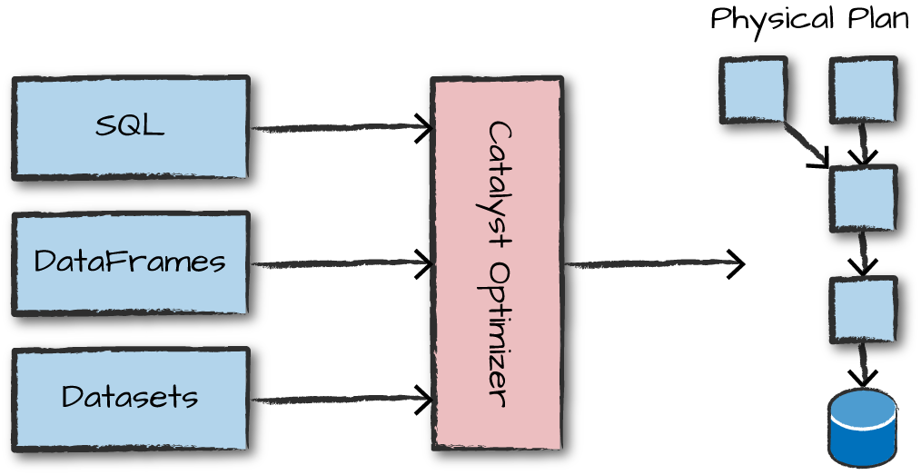

*Figure 4-1. The Catalyst Optimizer*

**Logical Planning**

The first phase of execution is meant to take user code and convert it into a logical plan. Figure 4-2 illustrates this process.

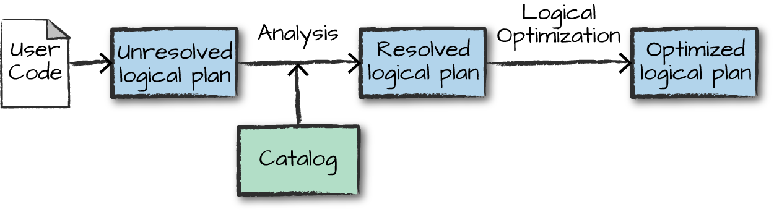

*Figure 4-2. The structured API logical planning process*

This logical plan only represents a set of abstract transformations that do not refer to executors or drivers, it’s purely to convert the user’s set of expressions into the most optimized version. It does this by converting user code into an *unresolved logical plan*. This plan is unresolved because although your code might be valid, the tables or columns that it refers to might or might not exist. Spark uses the *catalog*, a repository of all table and DataFrame information, to *resolve* columns and tables in the *analyzer*. The analyzer might reject the unresolved logical plan if the required table or column name does not exist in the catalog. If the analyzer can resolve it, the result is passed through the Catalyst Optimizer, a collection of rules that attempt to optimize the logical plan by pushing down predicates or selections. Packages can extend the Catalyst to include their own rules for domain-specific optimizations.

**Physical Planning**

After successfully creating an optimized logical plan, Spark then begins the physical planning process. The *physical plan*, often called a Spark plan, specifies how the logical plan will execute on the cluster by generating different physical execution strategies and comparing them through a cost model, as depicted in Figure 4-3. An example of the cost comparison might be choosing how to perform a given join by looking at the physical attributes of a given table (how big the table is or how big its partitions are).

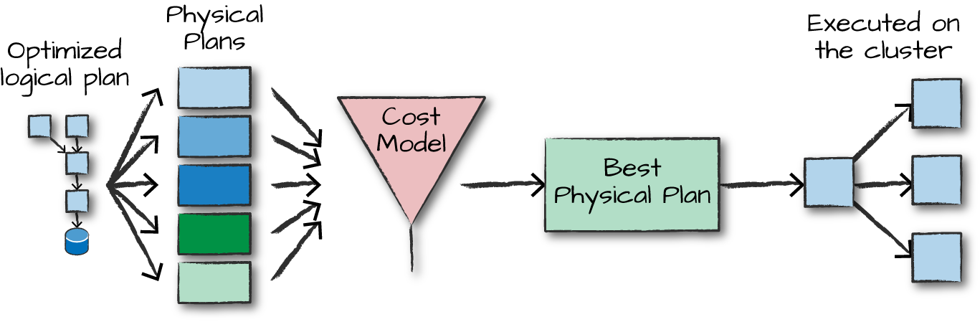

*Figure 4-3. The physical planning process*

Physical planning results in a series of RDDs and transformations. This result is why you might have heard Spark referred to as a compiler—it takes queries in DataFrames, Datasets, and SQL and compiles them into RDD transformations for you.

**Execution**

Upon selecting a physical plan, Spark runs all of this code over RDDs, the lower-level programming interface of Spark (which we cover in [Part III](https://www.safaribooksonline.com/library/view/spark-the-definitive/9781491912201/part03.html#part3)). Spark performs further optimizations at runtime, generating native Java bytecode that can remove entire tasks or stages during execution. Finally the result is returned to the user.

**Conclusion**

In this chapter, we covered Spark Structured APIs and how Spark transforms your code into what will physically execute on the cluster. In the chapters that follow, we cover core concepts and how to use the key functionality of the Structured APIs.